Catalog

**Beetle(4 variation)**

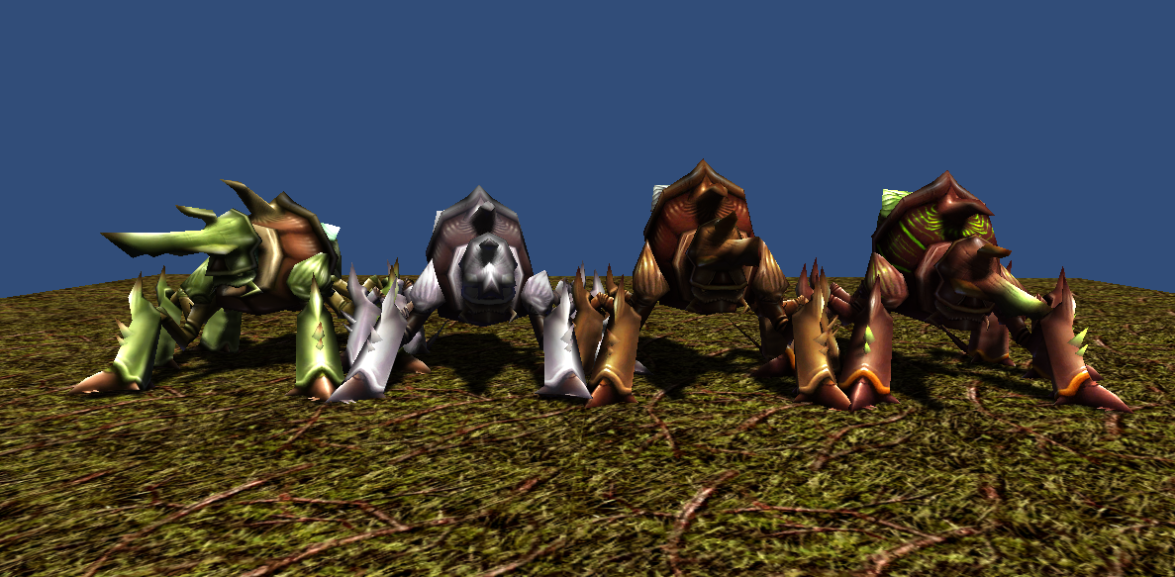

1066 polygons  
512x512x32bit 1 texture   
5 animations(idle, move, attack, beaten, die)

**Gargoyle(5 variation)**

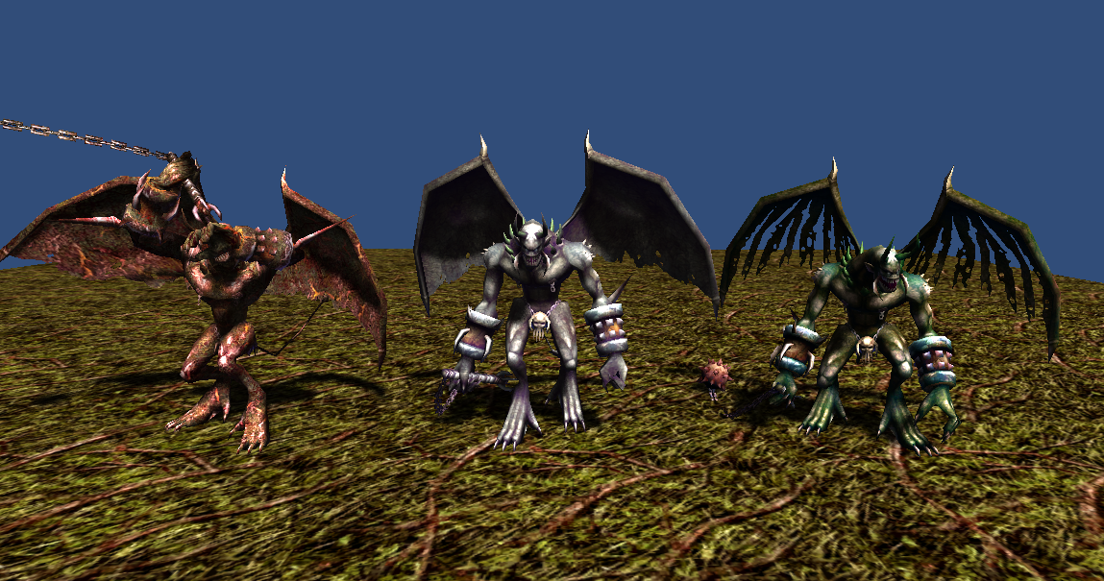

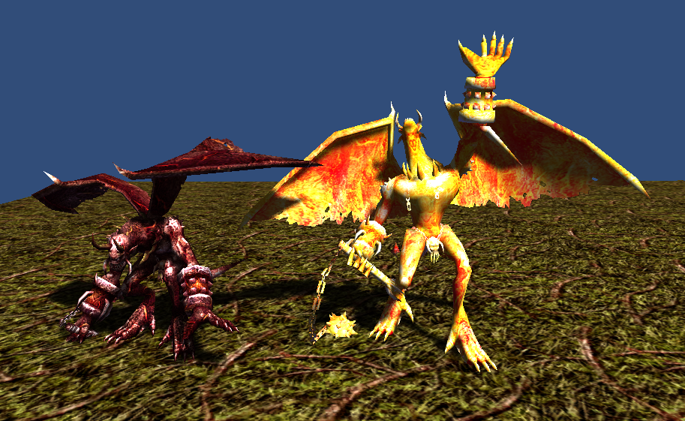  
2880 polygons  
512x512x32bit 1 texture

5 animations(idle, move, attack, beaten, die)

**Frakatia(3 variation)**

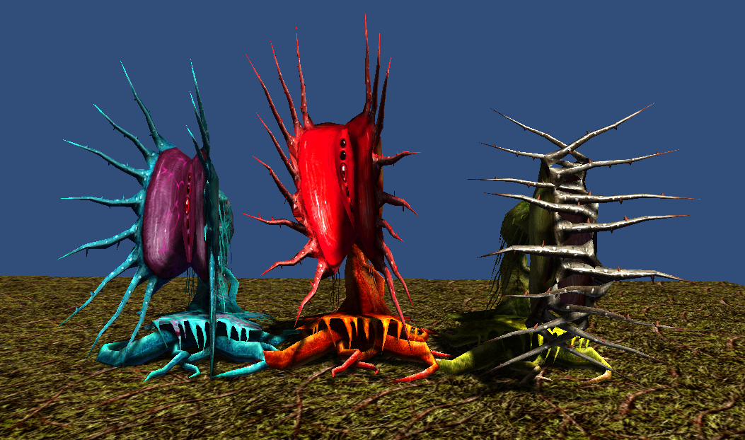

1694 polygons  
512x512x32bit 1 texture  
5 animations(idle, move, attack, beaten, die)

**Hell Hound(2 variation)**

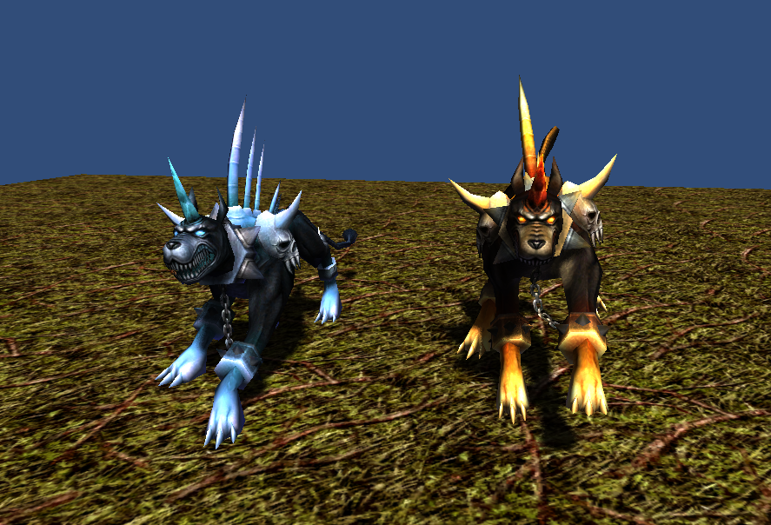

1360 polygons  
512x512x32bit 1 texture  
6 animations(idle, move, attack1, attack2, beaten, die)

**Thank you for download.**

**Contact**

Homepage : http://www.studioez.net

E-Mail : admin@studioez.net